ORGANIZATIONAL DETAILS  Teachers  For further information, please contact:  Ms Rizakou, tel.: +30 2108200195, fax.: +30 2108200222,  rizakou@elinyae.gr (registration and organizational details).  Ms Lomi, tel.: +30 6946704705, fax.: +30 2109493331,  con.lomi@gmail.com (seminar topics). | TARGET OF WORKSHOP  Organized by ELINYAE  In collaboration with the  Department of Occupational Health  “CLINICA DEL LAVORO”  University of Milan (Italy) |   Ergonomic of Posture and  Movement Research Unit  Athens 7 June 2007  8.30 – 12.30  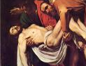  Free Seminar on  Venue: Hellenic Institute for Occupational Health and Safety (ELINYAE)  143 Liosion Str. & 6 Thirsiou Str. (3rd floor).
  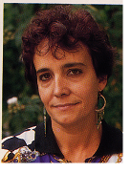 | Olga Menoni: an occupational therapist and an ergonomist member of EPM (Ergonomics of Posture and Movement) Research Unit since its origin in 1985. She published several papers on work-related musculoskeletal disorders. Since 1994 she has been employed in health care workers’ MSD prevention. She has taught in approx 150 courses on risk assessment of load manual handling in hospitals and training and education of “educators” for MSD prevention.  e-mail: epmospedali@tiscali.it
  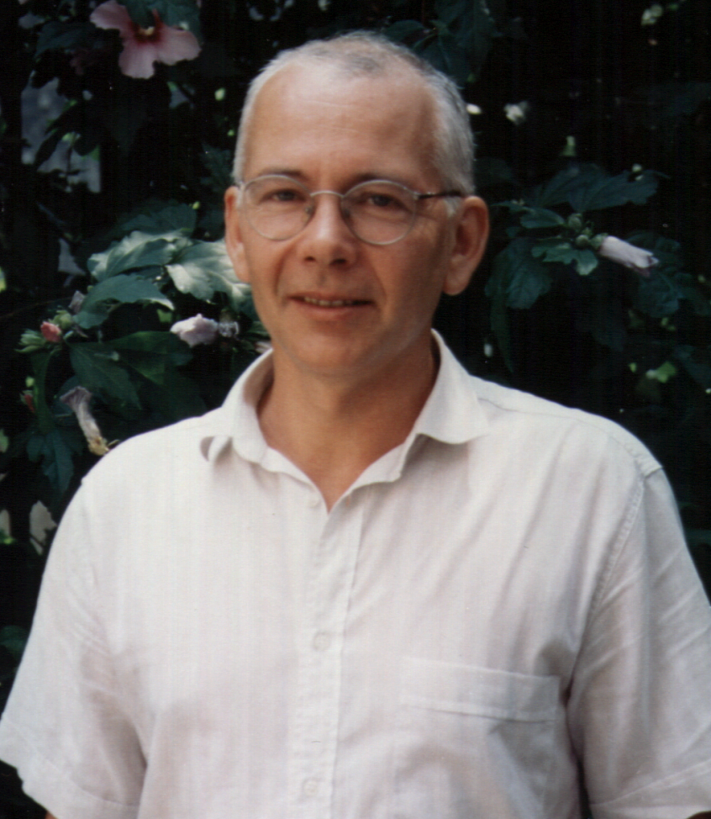 | Battevi Natale: an occupational physician since 1982. Specialist in medical Statistics. A teacher at the post graduate School of Psychiatry at the Milan University. A researcher of the EPM Research Unit from 1997. He has taught in several education and training courses for risk assessment of load manual handling in hospitals and training and education of “educators” for prevention of damages from non cooperative patient manual handling.  e-mail: epmnatale@tiscali.it
  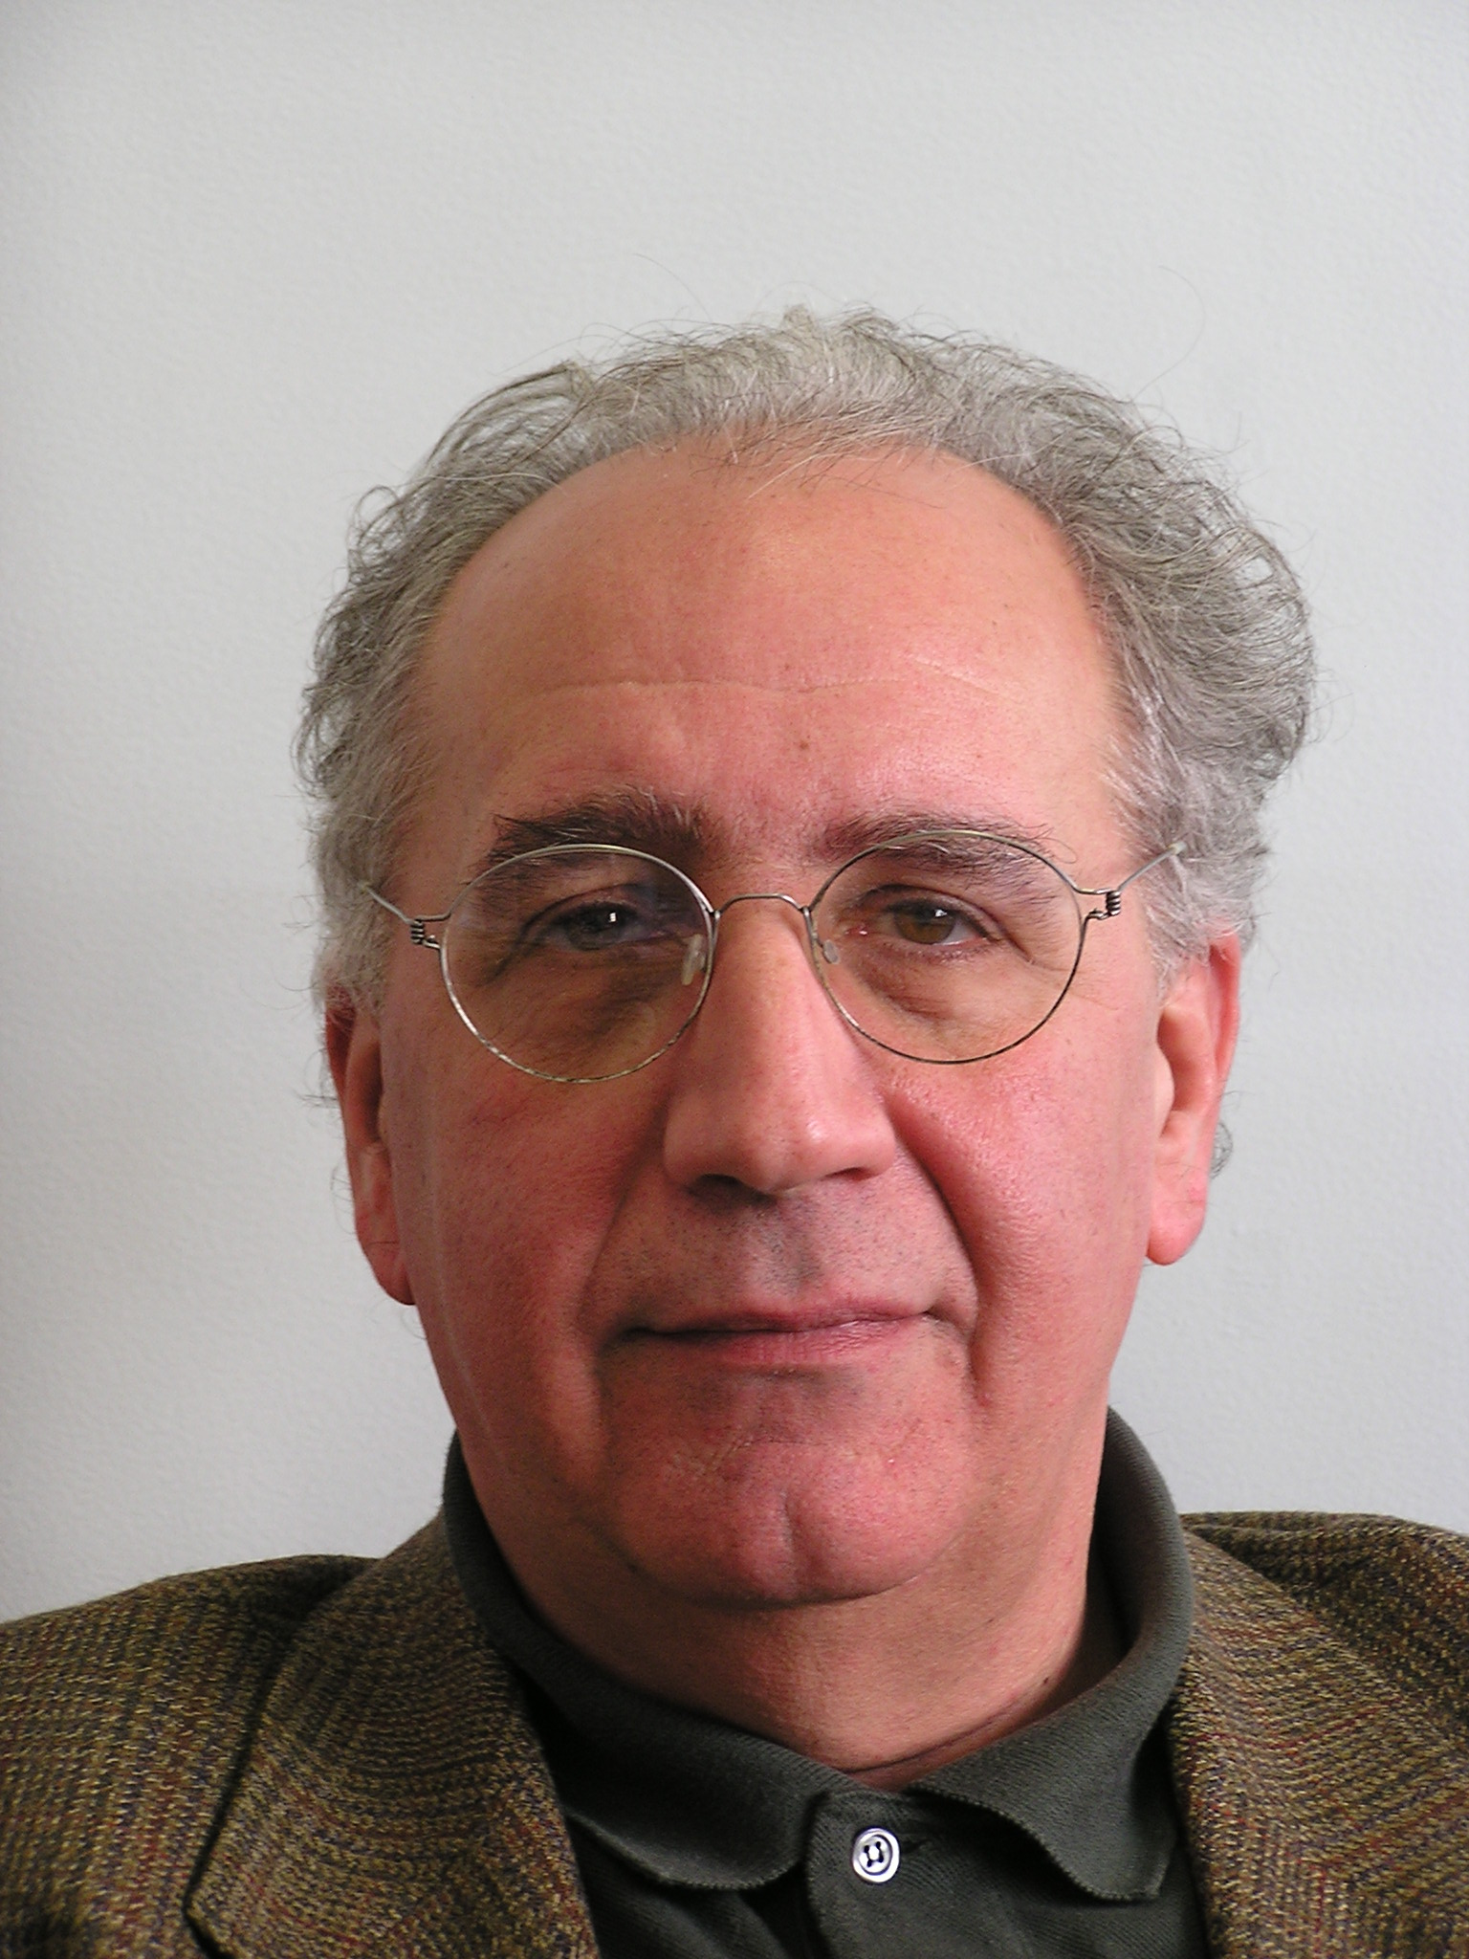 | Enrico Occhipinti, a physician and a certified European ergonomist, he is the head of the Occupational Medicine Centre (CEMOC) of the Preventive Medicine Department of the Clinica del Lavoro of Milan. He is a lecturer at the Postgraduate School of Occupational Health of the Milan University. He is the president of the EPM Research Unit.  e-mail: epmenrico@tiscali.it
  The Ergonomics Posture and Movement (EPM) Research Unit (www.epmresearch.org) has delivered for many years now several ergonomic courses specially focused on workers’ MSD prevention.
  Since 1996 a method for risk assessment in Patient Manual Handling (MAPO index) has been set up for use in acute and chronic patients’ wards.
  A first multicentre study carried out in 1997-1999 allowed to estimate the relationship between MAPO index risk and lumbar damage (published in the journal “La Medicina del Lavoro – Vol. 90, n° 2 – March - April 1999). In 2001-2003, a second multicentre study essentially confirmed these results (published in Ergonomics Vol. 49, No. 7, 10 June 2006, 671–687).
  The method starts to be used in Europe (United Kingdom, Portugal) and is widespread in Italy.
  During the Seminar, theoretical and ergonomic assumptions will be illustrated as well as practical applications of MAPO, with examples facilitating understanding.

“RISK ASSESSMENT WITH THE MAPO METHOD IN PATIENT MANUAL HANDLING”

Thursday 7 June 2007 – Athens
Hellenic Institute for Occupational Health and Safety (ELINYAE):
143 Liosion str. & 6 Thirsiou str., (3rd floor)

Participation is free of charge and language is English.

Seminar Schedule
A CD-ROM with observation protocols and related legends in English, as well as a software for MAPO index calculation, special references and material (protocols) for practical exercises, will be distributed to the seminar participants.

start | end | TOPICS
8.30 | 10.30 | Introduction on epidemiological issues in health care workers’ spinal diseases
 |  | National and international method experiences for risk assessment in patient manual handling
 |  | Methods and criteria for spine biomechanical overload assessment of health care workers manually handling patients
 |  | The MAPO method for risk assessment in patient manual handling in hospital wards: organizational, environmental and equipment issues
 |  | Observation protocols and methods defining risk determinant scores
10.30 | 11.15 | Practical exercises on risk assessment in wards (MAPO) through simulation filling in the analytical protocol
11.15 | 12.00 | Guided correction of MAPO check list in plenary session and discussion
12.00 | 12.30 | RISK MAPPING
 |  | Presentation of software for automatic calculation of MAPO index
 |  | Criteria for ergonomic redesign
 |  | Discussion

Secretary of EPM: Daniela Fano e-mail: ergonomia@unimi.it

